**TCP/IP Practicals - End Term**

Name : Aditya Shivram Mahajan

Branch : Computer Science

Reg No. : 2017BCS001

Roll No. : A10

Year : Final Year

## horizontal line

Index

Practical 1 : Write a program for Subnet design

(Classless addressing). - link

Practical 2 : Write a program for IP Header Checksum

Calculation. - link

Practical 3 : Write a program for Socket programming. - link

Practical 4 : Write a script to create a static Web Document/Web page (For example: Your Resume). - link

Practical 5 : Study the following commands and utilities - Ping, Traceroute/Tracert, Ipconfig/Ifconfig. - link

## horizontal line

**Practical 1 : Write a program for Subnet design (Classless addressing).**

**Theory:**

The concept of subnet was introduced to address the following requirement. Consider an internet that includes one or more WANs and a number of sites, each of which has a number of LANs. We would like to allow arbitrary complexity of interconnected LAN structures within an organization while insulating the overall internet against explosive growth in network numbers and routing complexity.

One approach to this problem is to assign a single network number to all of the LANs at a site. From the point of view of the rest of the internet, there is a single network at that site, which simplifies addressing and routing. To allow the routers within the site to function properly, each LAN is assigned a subnet number. The host portion of the internet address is partitioned into a subnet number and a host number to accommodate this new level of addressing.

To reduce the wastage of IP addresses in a block, we use subnetting. What we do is that we use host id bits as net id bits of a classful IP address. We give the IP address and define the number of bits for the mask along with it (usually followed by a ‘/’ symbol), like, 192.168.1.1/28. Here, the subnet mask is found by putting the given number of bits out of 32 as 1, like, in the given address, we need to put 28 out of 32 bits as 1 and the rest as 0, and so, the subnet mask would be 255.255.255.240.

**Some values calculated in subnetting :**

1. Number of subnets : Given bits for mask – No. of bits in default mask

2. Subnet address : AND result of subnet mask and the given IP address

3. Broadcast address : By putting the host bits as 1 and retaining the network bits as in the IP

address

4. Number of hosts per subnet : 2(32 – Given bits for mask) – 2

5. First Host ID : Subnet address + 1 (adding one to the binary representation of the subnet address)

**Program :**

|  |
| --- |
| #include <stdio.h> #include <string.h> #include <math.h>  void extractIpAddress(unsigned char * sourceString, short * ipAddress) {  unsigned short len = 0;  unsigned char oct[5] = {0}, cnt = 0, cnt1 = 0, i, buf[8];  len = strlen(sourceString);  for (i = 0; i < len; i++) {  if (sourceString[i] != '.') {  buf[cnt++] = sourceString[i];  }  if (sourceString[i] == '.' || i == len - 1 || sourceString[i] == '/') {  buf[cnt] = '\0';  cnt = 0;  oct[cnt1++] = atoi(buf);  }  }  ipAddress[0] = oct[0];  ipAddress[1] = oct[1];  ipAddress[2] = oct[2];  ipAddress[3] = oct[3];  ipAddress[4] = oct[4]; } int main() {  unsigned char ip[20] = {0};  short ipAddress[5];  short ipAddress1[4];  short ipAddress2[4];  short ipAddress3[4];  short nwprefix, suffix, newnwprefix;  short initaddr[4];  int mask;  int ntk[32];  int subs, sizeofblock, remaining, addr;  printf("Enter a Classless IP Block: ");  scanf("%s", ip);  printf("Enter number of subnets: ");  scanf("%d", & subs);  extractIpAddress(ip, & ipAddress[0]);  printf("Ip Address: %  d. % d. % d. % d / % d\n ",ipAddress[0],ipAddress[1],ipAddress[2],ipAddress[3],ipAddress[4]);  sizeofblock = (int) pow(2, 32 - ipAddress[4]);  if (ipAddress[3] % sizeofblock == 0) {  printf("It is a valid CIDR block\n");  } else {  printf("It is not a valid CIDR block\n");  exit(0);  }  newnwprefix = ipAddress[4] + (int)(floor(log(subs) / log(2))); printf("Length of new subnet mask=%d\n", newnwprefix); remaining = 32 - newnwprefix; addr = (int) pow(2, remaining); printf("Number of addresses per subnet: %d\n", addr); ipAddress1[0] = (addr - 1 >> 24) & 0xFF; ipAddress1[1] = (addr - 1 >> 16) & 0xFF; ipAddress1[2] = (addr - 1 >> 8) & 0xFF; ipAddress1[3] = addr - 1 & 0xFF; printf("Range of first subnet: %d.%d.%d.%d/%d - %  d. % d. % d. % d / % d\n ",ipAddress[0],ipAddress[1],ipAddress[2],ipAddress[3],newnwprefix,ipAddress[  0] + ipAddress1[0], ipAddress[1] + ipAddress1[1], ipAddress[2] + ipAddress1[2], ipAddress[3] + ipAddress 1[3], newnwprefix);    ipAddress1[0] = (sizeofblock - 1 >> 24) & 0xFF;  ipAddress1[1] = (sizeofblock - 1 >> 16) & 0xFF;  ipAddress1[2] = (sizeofblock - 1 >> 8) & 0xFF;  ipAddress1[3] = sizeofblock - 1 & 0xFF;  ipAddress2[0] = ipAddress1[0] + ipAddress[0];  ipAddress2[1] = ipAddress1[1] + ipAddress[1];  ipAddress2[2] = ipAddress1[2] + ipAddress[2];  ipAddress2[3] = ipAddress1[3] + ipAddress[3];  ipAddress3[0] = (addr - 1 >> 24) & 0xFF;  ipAddress3[1] = (addr - 1 >> 16) & 0xFF;  ipAddress3[2] = (addr - 1 >> 8) & 0xFF;  ipAddress3[3] = addr - 1 & 0xFF;    printf("Range of last subnet: %d.%d.%d.%d/%d - %d.%d.%d.%d/%d", ipAddress2[0] -  ipAddress3[0], ipAddress2[1] - ipAddress3[1], ipAddress2[2] - ipAddress3[2], ipAddress2[3] -  ipAddress3[3], newnwprefix, ipAddress2[0], ipAddress2[1], ipAddress2[2], ipAddress2[3], newnwprefix); } |

**Output :**

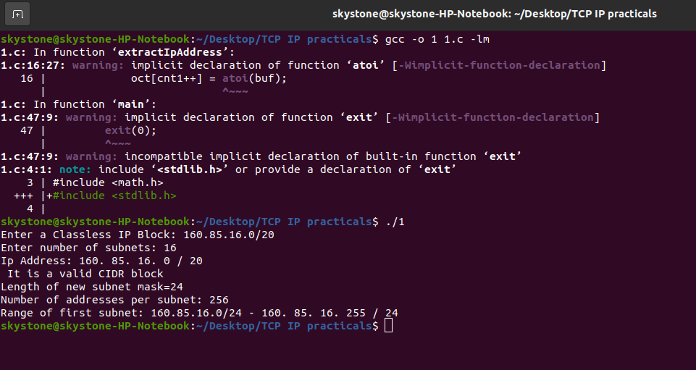

## horizontal line

**Practical 2 : Write a program for IP Header Checksum Calculation.**

**Theory :**

The IPv4 header checksum is a checksum used in version 4 of the Internet Protocol (IPv4) to detect corruption in the header of IPv4 packets. It is carried in the IP packet header, and represents the 16-bit result of summation of the header words.

What is Checksum :

A check sum is basically a value that is computed from a data packet to check its integrity. Through integrity, we mean a check on whether the data received is error free or not. This is because while traveling on the network a data packet can become corrupt and there has to be a way at the receiving end to know that data is corrupted or not. This is the reason the checksum field is added to the header. At the source side, the checksum is calculated and set in the header as a field. At the destination side, the checksum is again calculated and cross checked with the existing checksum value in the header to see if the data packet is OK or not.

IP Header Checksum :

The IPv6 protocol does not use header checksums. Its designers considered that the whole-packet link layer checksumming provided in protocols, such as PPP and Ethernet, combined with the use of checksums in upper layer protocols such as TCP and UDP, are sufficient.[1] Thus, IPv6 routers are relieved of the task of recomputing the checksum whenever the packet changes, for instance by the lowering of the Hop limit counter on every hop.

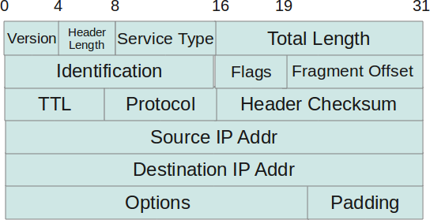

**Program :**

|  |
| --- |
| #include <unistd.h> #include <stdio.h> #include <stdlib.h> #include <sys/socket.h> #include <netinet/ip.h> #include <netinet/udp.h> #include<arpa/inet.h> #define PCKT_LEN 8192  struct ipheader {  unsigned char iph_ihl: 5, iph_ver: 4;  unsigned char iph_tos;  unsigned short int iph_len;  unsigned short int iph_ident;  unsigned char  iph_flag;  unsigned short int iph_offset;  unsigned char iph_ttl;  unsigned char iph_protocol;  unsigned short int iph_chksum;  unsigned int iph_sourceip;  unsigned int iph_destip;  unsigned short ip_offset;  unsigned short ip_checksum; };  unsigned short csum(unsigned short * buf, int nwords) {  unsigned long sum;  for (sum = 0; nwords > 0; nwords--)  sum += * buf++;  sum = (sum >> 16) + (sum & 0xffff);  sum += (sum >> 16);  return (unsigned short)(~sum); }  int main(int argc, char * argv[]) {  int sd;  char buffer[PCKT_LEN];  struct ipheader * ip = (struct ipheader * ) buffer;  ip -> iph_ihl = 5;  ip -> iph_ver = 4;  ip -> iph_tos = 0;  ip -> ip_offset = 0;  ip -> ip_checksum = 0;  ip -> iph_flag = 0;  ip -> iph_len = sizeof(struct ipheader) + atoi(argv[3]);  ip -> iph_ident = htons(atoi(argv[4]));  ip -> iph_ttl = argv[5];  ip -> iph_protocol = argv[6];  ip -> iph_sourceip = inet_addr(argv[1]);  ip -> iph_destip = inet_addr(argv[2]);  ip -> iph_chksum = csum((unsigned short * ) buffer, ip -> iph_len);  printf("%x\n", ip -> iph_chksum); } |

**Output :**

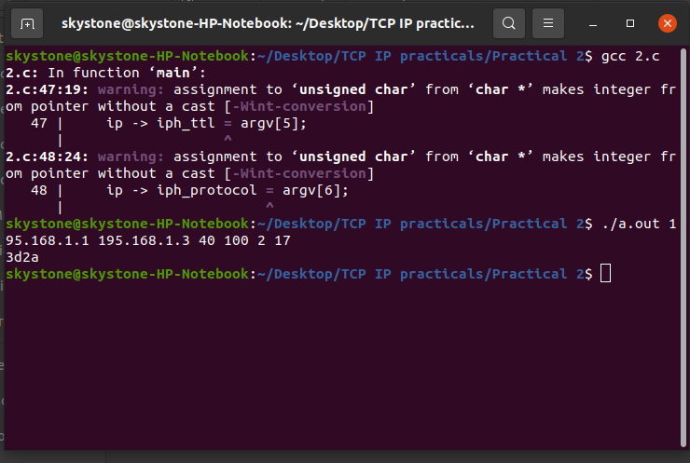

horizontal line

**Practical 3 : Write a program for Socket programming.**

**Theory :**

**What is socket programming?**

Socket programming is a way of connecting two nodes on a network to communicate with each other. One socket(node) listens on a particular port at an IP, while other socket reaches out to the other to form a connection. Server forms the listener socket while client reaches out to the server.

**Program : Server.py**

|  |
| --- |
| import socket import threading  HEADER = 64 PORT = 5050 SERVER = "192.168.1.105" #SERVER = socket.gethostbyname(socket.gethostname()) ADDR = (SERVER, PORT) FORMAT = 'utf-8' DISCONNECT_MESSAGE = "!DISCONNECT"  server = socket.socket(socket.AF_INET, socket.SOCK_STREAM) server.bind(ADDR)  def handle_client(conn, addr):  print(f"[NEW CONNECTION] {addr} connected.")   connected = True  while connected:  msg_length = conn.recv(HEADER).decode(FORMAT)  if msg_length:  msg_length = int(msg_length)  msg = conn.recv(msg_length).decode(FORMAT)  if msg == DISCONNECT_MESSAGE:  connected = False   print(f"[{addr}] {msg}")  conn.send("Msg received".encode(FORMAT))   conn.close()    def start():  server.listen()  print(f"[LISTENING] Server is listening on {SERVER}")  while True:  conn, addr = server.accept()  thread = threading.Thread(target=handle_client, args=(conn, addr))  thread.start()  print(f"[ACTIVE CONNECTIONS] {threading.activeCount() - 1}")   print("[STARTING] server is starting...") start() |

**Program : Client.py**

|  |
| --- |
| import socket  HEADER = 64 PORT = 5050 FORMAT = 'utf-8' DISCONNECT_MESSAGE = "!DISCONNECT" SERVER = "192.168.1.105" ADDR = (SERVER, PORT)  client = socket.socket(socket.AF_INET, socket.SOCK_STREAM) client.connect(ADDR)  def send(msg):  message = msg.encode(FORMAT)  msg_length = len(message)  send_length = str(msg_length).encode(FORMAT)  send_length += b' ' * (HEADER - len(send_length))  client.send(send_length)  client.send(message)  print(client.recv(2048).decode(FORMAT))  send("Hello World!") input() send("Hello Everyone!") input() send("Hello Tim!")  send(DISCONNECT_MESSAGE) |

**Output :**

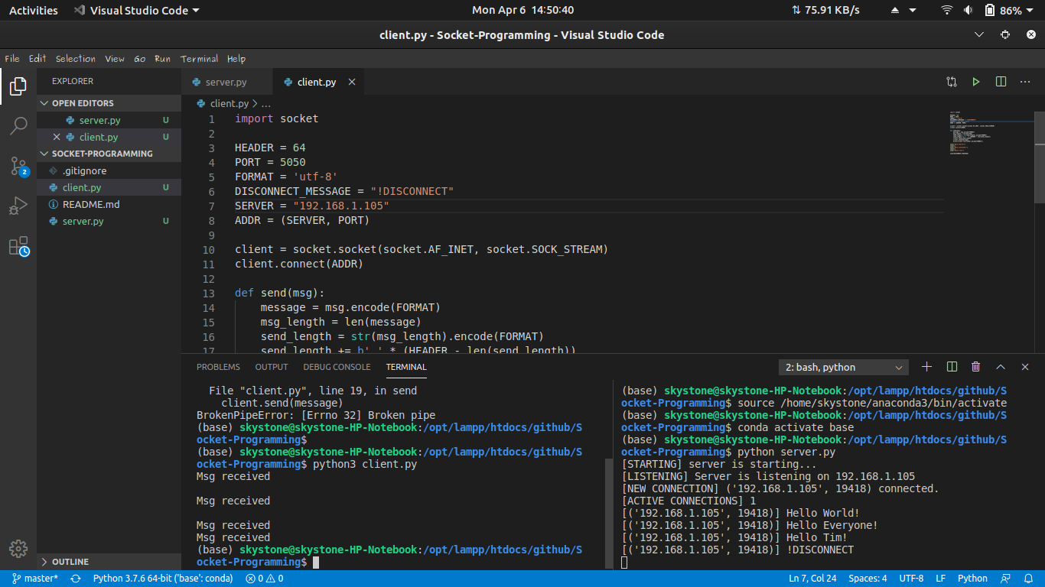

horizontal line

**Practical 4 : Write a script to create a static Web Document/Web page (For example: Your Resume).**

**HTML Code :**

|  |
| --- |
| <?php include './includes/header.php'; ?>  <style type="text/css">  .trans-card{  background-color: transparent;  }   html,  body,  header,  .view {  height: 100%;  }   .intrests:hover {  box-shadow: 0px 0px 40px 16px rgba(18,18,18,1.00);  }   @media (max-width: 740px) {  html,  body,  header,  .view {  height: 1000px;  }  }   @media (min-width: 800px) and (max-width: 850px) {  html,  body,  header,  .view {  height: 650px;  }  }  @media (min-width: 800px) and (max-width: 850px) {  .navbar:not(.top-nav-collapse) {  background: #1C2331!important;  }  }  </style>  <!-- Full Page Intro --> <div class="view full-page-intro" style="background-image: url('https://mdbootstrap.com/img/Photos/Others/images/78.jpg'); background-repeat: no-repeat; background-size: cover;">   <!-- Mask & flexbox options-->  <div class="mask rgba-black-light d-flex justify-content-center align-items-center">   <!-- Content -->  <div class="container">  <br><br><br>  <!--Grid row-->  <div class="row wow fadeIn">  <!--Grid column-->  <div class="col-md-6 mb-4 white-text text-center text-md-left">  <h1 class="display-4 font-weight-bold">Hello There <br>Aditya Mahajan Here... !!!</h1>  <hr class="hr-light">  <p>  <strong>Well inshort about me?? &#128521; </strong>  </p>  <p class="mb-4 d-none d-md-block">  <strong>Currently pursing B.Tech Computer Science from Shri Guru Gobind Singhji Institute of engineering and technology,Vishnupuri, Nanded, Maharashtra. </strong>  </p>   <a href="myProjects.php" class="btn btn-indigo btn-lg">Projects  <i class="fas fa-graduation-cap ml-2"></i>  </a>  </div>  <!--Grid column-->  <!--Grid column-->  <div class="col-md-6 col-xl-5 mb-4">  <!--Card-->  <div class="card trans-card z-depth-5">  <!--Card content-->  <div class="intrests card-body">  <!-- Form -->  <form name="" class="white-text opacity-50 ">  <!-- Heading -->  <h3 class="text-center">  <strong>Things I like to Do...</strong>  </h3>  <hr>  <ul>  <li>Coding (Mostly in C++ and Python) <i class="fa fa-code"></i></li>  </ul>  <ul>  <li>Problem Solving (Algorithms)</li>  </ul>  <ul>  <li>Photography <i class="fa fa-camera"></i></li>  </ul>  <ul>  <li>Cooking <i class="fa fa-cutlery" aria-hidden="true"></i></li>  </ul>  <ul>  <li>Travelling</li>  </ul>  <ul>  <li>Lawn Tennis, Gymnastics, Skating </i></li>  </ul>     <!-- <div class="md-form">  <i class="fas fa-user prefix grey-text"></i>  <input type="text" id="form3" class="form-control">  <label for="form3">Your name</label>  </div>  <div class="md-form">  <i class="fas fa-envelope prefix grey-text"></i>  <input type="text" id="form2" class="form-control">  <label for="form2">Your email</label>  </div>  <div class="md-form">  <i class="fas fa-pencil-alt prefix grey-text"></i>  <textarea type="text" id="form8" class="md-textarea"></textarea>  <label for="form8">Your message</label>  </div>  <div class="text-center">  <button class="btn btn-indigo">Send</button>  <hr>  <fieldset class="form-check">  <input type="checkbox" class="form-check-input" id="checkbox1">  <label for="checkbox1" class="form-check-label dark-grey-text">Subscribe me to the newsletter</label>  </fieldset>  </div> -->  </form>  <!-- Form -->  </div>  </div>  <!--/.Card-->  </div>  <!--Grid column-->  </div>  <!--Grid row-->  </div>  <!-- Content -->  </div>  <!-- Mask & flexbox options--> </div> <!-- Full Page Intro -->   <?php include './includes/footer.php'; ?> |

**Output :**



horizontal line

**Practical 5 : Study the following commands and utilities**

**Ping, Traceroute/Tracert, Ipconfig/Ifconfig.**

**Theory :**

**Ping**

Ping is a computer network administration software utility used to test the reachability of a host on an Internet Protocol (IP) network. It is available for virtually all operating systems that have networking capability, including most embedded network administration software.

Ping measures the round-trip time for messages sent from the originating host to a destination computer that are echoed back to the source. The name comes from active sonar terminology that sends a pulse of sound and listens for the echo to detect objects under water.[1]

Ping operates by sending Internet Control Message Protocol (ICMP) echo request packets to the target host and waiting for an ICMP echo reply. The program reports errors, packet loss, and a statistical summary of the results, typically including the minimum, maximum, the mean round-trip times, and standard deviation of the mean.

The command-line options of the ping utility and its output vary between the numerous implementations. Options may include the size of the payload, count of tests, limits for the number of network hops (TTL) that probes traverse, interval between the requests and time to wait for a response. Many systems provide a companion utility ping6, for testing on Internet Protocol version 6 (IPv6) networks, which implement ICMPv6.

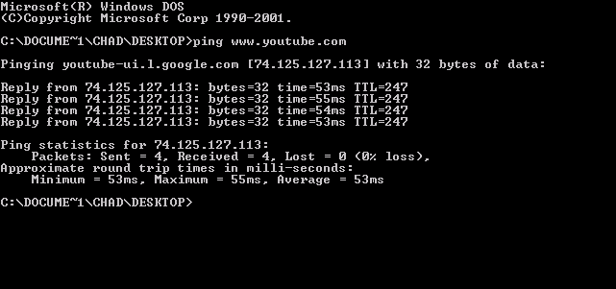

**Traceroute/Tracert**

In computing, traceroute and tracert are computer network diagnostic commands for displaying possible routes (paths) and measuring transit delays of packets across an Internet Protocol (IP) network. The history of the route is recorded as the round-trip times of the packets received from each successive host (remote node) in the route (path); the sum of the mean times in each hop is a measure of the total time spent to establish the connection. Traceroute proceeds unless all (usually three) sent packets are lost more than twice; then the connection is lost and the route cannot be evaluated. Ping, on the other hand, only computes the final round-trip times from the destination point.

For Internet Protocol Version 6 (IPv6) the tool sometimes has the name traceroute6 or tracert6.

|  |
| --- |
| $ traceroute -w 3 -q 1 -m 16 example.com |

**Ipconfig/Ifconfig**

ifconfig is a system administration utility in Unix-like operating systems for network interface configuration.

The utility is a command-line interface tool and is also used in the system startup scripts of many operating systems. It has features for configuring, controlling, and querying TCP/IP network interface parameters. Ifconfig originally appeared in 4.2BSD as part of the BSD TCP/IP suite.

